The maps below show an industrial area in the town of Norbiton, and planned future development of the site

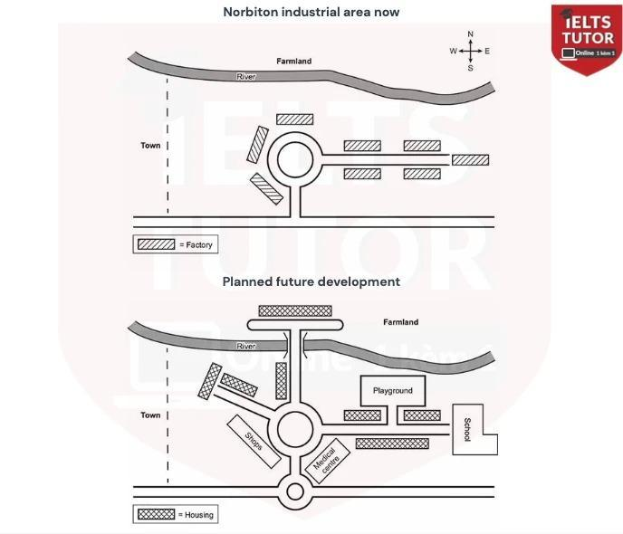

* Cách viết dạng map <https://www.ieltstutor.me/blog/map>

Given are the maps illustrating the recent positions of facilities in Norbiton town and the planned further reconstruction of this site. Overall, it is apparent that there will be more housing places in the middle of the site and several new public facilities. **→ Thông tin ở đây thì mình sẽ lấy cái trọng điểm nhất là [factory] bị mất đi - cái nơi này sẽ dành cho housing thôi nhé**

**VD:  
[future housing or services for residents’ need will replace all the factory]**

Regarding the recent map, the river divide the town into two main sites: a farmland on the top and an industrialized section on another side. There is a roundabout in the middle of the industrial section, which is surrounded by several factories. Moreover, factories are also situated along the East road.

In terms of the forthcoming enhancement, in the Northside, it is planned to construct a new bridge connecting the two sides of the town. In the middle, several factories are planned to build in a new subroad on the Westside as well as along the road heading East. Significantly, some new facilites including playground, shops, medical centre and school will be built in this side while there will be a new construction of a roundabout in the bottom of the map. **⇒ Phần gạch chân là miêu tả thông tin mới, mình sẽ tương ứng với thân bài số 1 đã giới thiệu, để người đọc (examiner) theo dõi được bài và trình bày về sự thay đổi của mình nhé**

***VD:  
Roundabout will remain, but with further connecting roads that head to the north, west and south (không có east, vì con đường này trước đó có rồi.***

* ***Towards the north - bridge***
* ***South - another roundabout, but at smaller size***
* ***East - Factories will all be replaced by residential housing***

175 words.

* **Overall:**
  + **This area will be completely** [**transformed**](https://www.ieltstutor.me/blog/cach-dung-dong-tu-transform-tieng-anh) **into a residential area, and roads will be expanded.**
* **Body 1: Viết về map 1**
  + **At present, the area is located east of the town with a river running from the west to the east in the north, north of which is farmland. >> IELTS TUTOR lưu ý** [**Cách paraphrase từ "situated/located"**](https://www.ieltstutor.me/blog/cach-paraphrase-tu-situated-located-dien-dat-cu-ngu-nam-o-tieng-anh)
  + **On the eastern side, outside the town, there is a road connecting eight factories with only one roundabout, which is located in the center of the area.**
  + **Three factories are near the roundabout while the other five** [**converge**](https://www.ieltsdanang.vn/blog/cach-dung-dong-tu-converge-tieng-anh) **in the far east.**
* **Body 2: Viết về map 2**
  + **In the future, two new exits will be added to the roundabout. >> IELTS TUTOR lưu ý** [**Diễn đạt "yếu tố tương lai" tiếng anh (Paraphrase "in the future")**](https://www.ieltstutor.me/blog/dien-dat-yeu-to-tuong-lai-ielts-paraphrase-in-the-future) 
    - **One heading northwest and the other north, which will cross a newly added bridge allowing access to new housing, leaving only the countryside in the northeast.**
  + **A small roundabout will be** [**constructed**](https://www.luyenthidaihoctienganhonline.com/blog/word-form-construct) **on the main road, linking to the large roundabout.**
  + **The factories will be replaced with housing and facilities such as shops and a medical centre.**
  + **A school will be built in the east with a new park located nearby. >> IELTS TUTOR lưu ý** [**CÁCH DÙNG TỪ "NEARBY" TIẾNG ANH**](https://www.ieltsdanang.vn/blog/ielts-phan-biet-nearby)